Question#4:

1. Explain Floyd-Warshall Algorithm.

Floyd-Warshall Algorithm is an algorithm for finding the shortest path between all the pairs of vertices in a weighted graph. This algorithm works for both the directed and undirected weighted graphs. But, it does not work for the graphs with negative cycles (where the sum of the edges in a cycle is negative).

A weighted graph is a graph in which each edge has a numerical value associated with it.

Floyd-Warhshall algorithm is also called as Floyd's algorithm, Roy-Floyd algorithm, Roy-Warshall algorithm, or WFI algorithm.

This algorithm follows the Dynamic programming approach to find the shortest paths.

**Working:**

We initialize the solution matrix same as the input graph matrix as a first step. Then we update the solution matrix by considering all vertices as an intermediate vertex. The idea is to one by one pick all vertices and updates all shortest paths which include the picked vertex as an intermediate vertex in the shortest path. When we pick vertex number k as an intermediate vertex, we already have considered vertices {0, 1, 2, .. k-1} as intermediate vertices. For every pair (i, j) of the source and destination vertices respectively, there are two possible cases.   
**1)** k is not an intermediate vertex in shortest path from i to j. We keep the value of dist[i][j] as it is.   
**2)** k is an intermediate vertex in shortest path from i to j. We update the value of dist[i][j] as dist[i][k] + dist[k][j] if dist[i][j] > dist[i][k] + dist[k][j]  
The following figure shows the above optimal substructure property in the all-pairs shortest path problem.

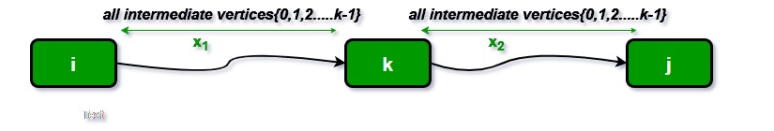

1. Solve the graph step by step using Floyd-Warshall algorithm.

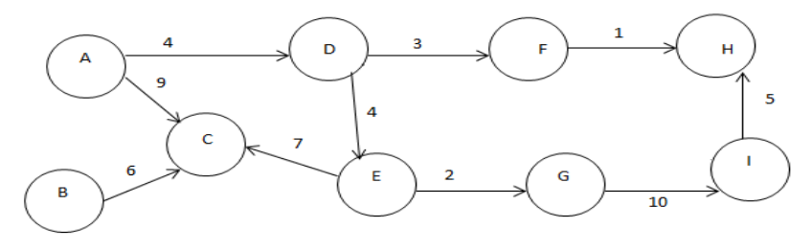

**Step-01:**

* Remove all the self loops and parallel edges (keeping the lowest weight edge) from the graph.
* In the given graph, there are neither self edges nor parallel edges.

**Step-02:**

* Write the initial distance matrix.
* It represents the distance between every pair of vertices in the form of given weights.
* For diagonal elements (representing self-loops), distance value = 0.
* For vertices having a direct edge between them, distance value = weight of that edge.
* For vertices having no direct edge between them, distance value = ∞.

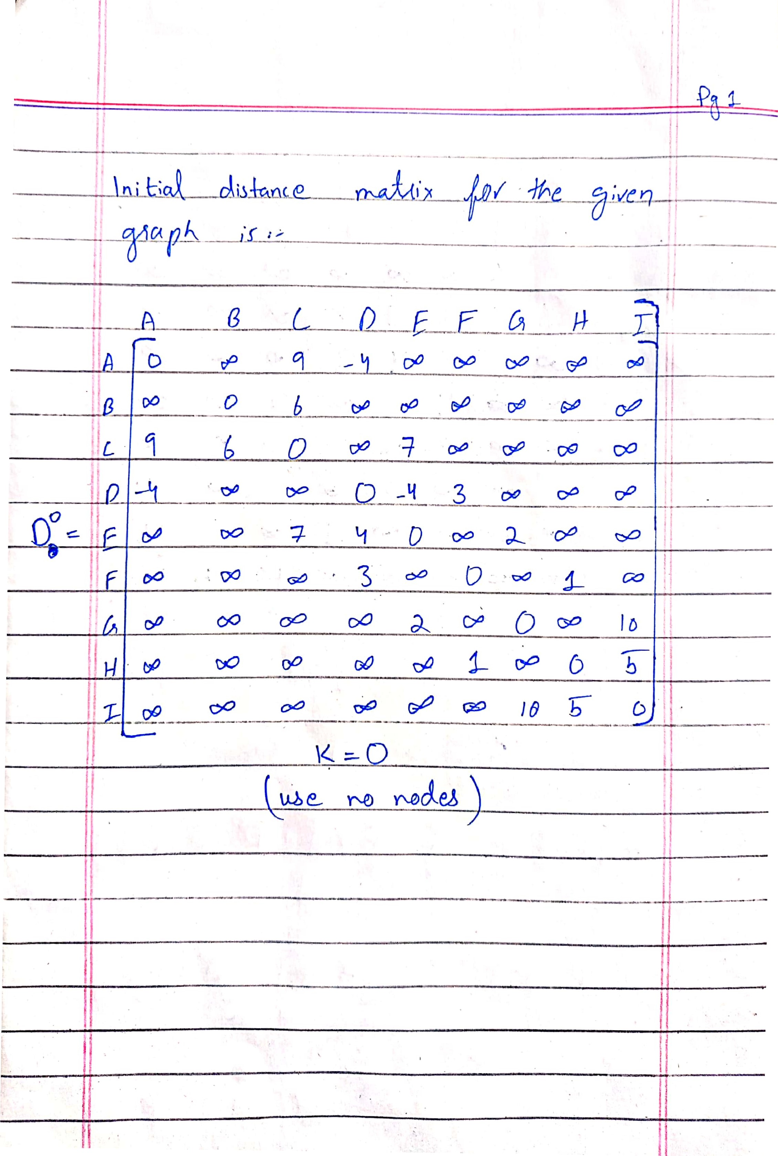

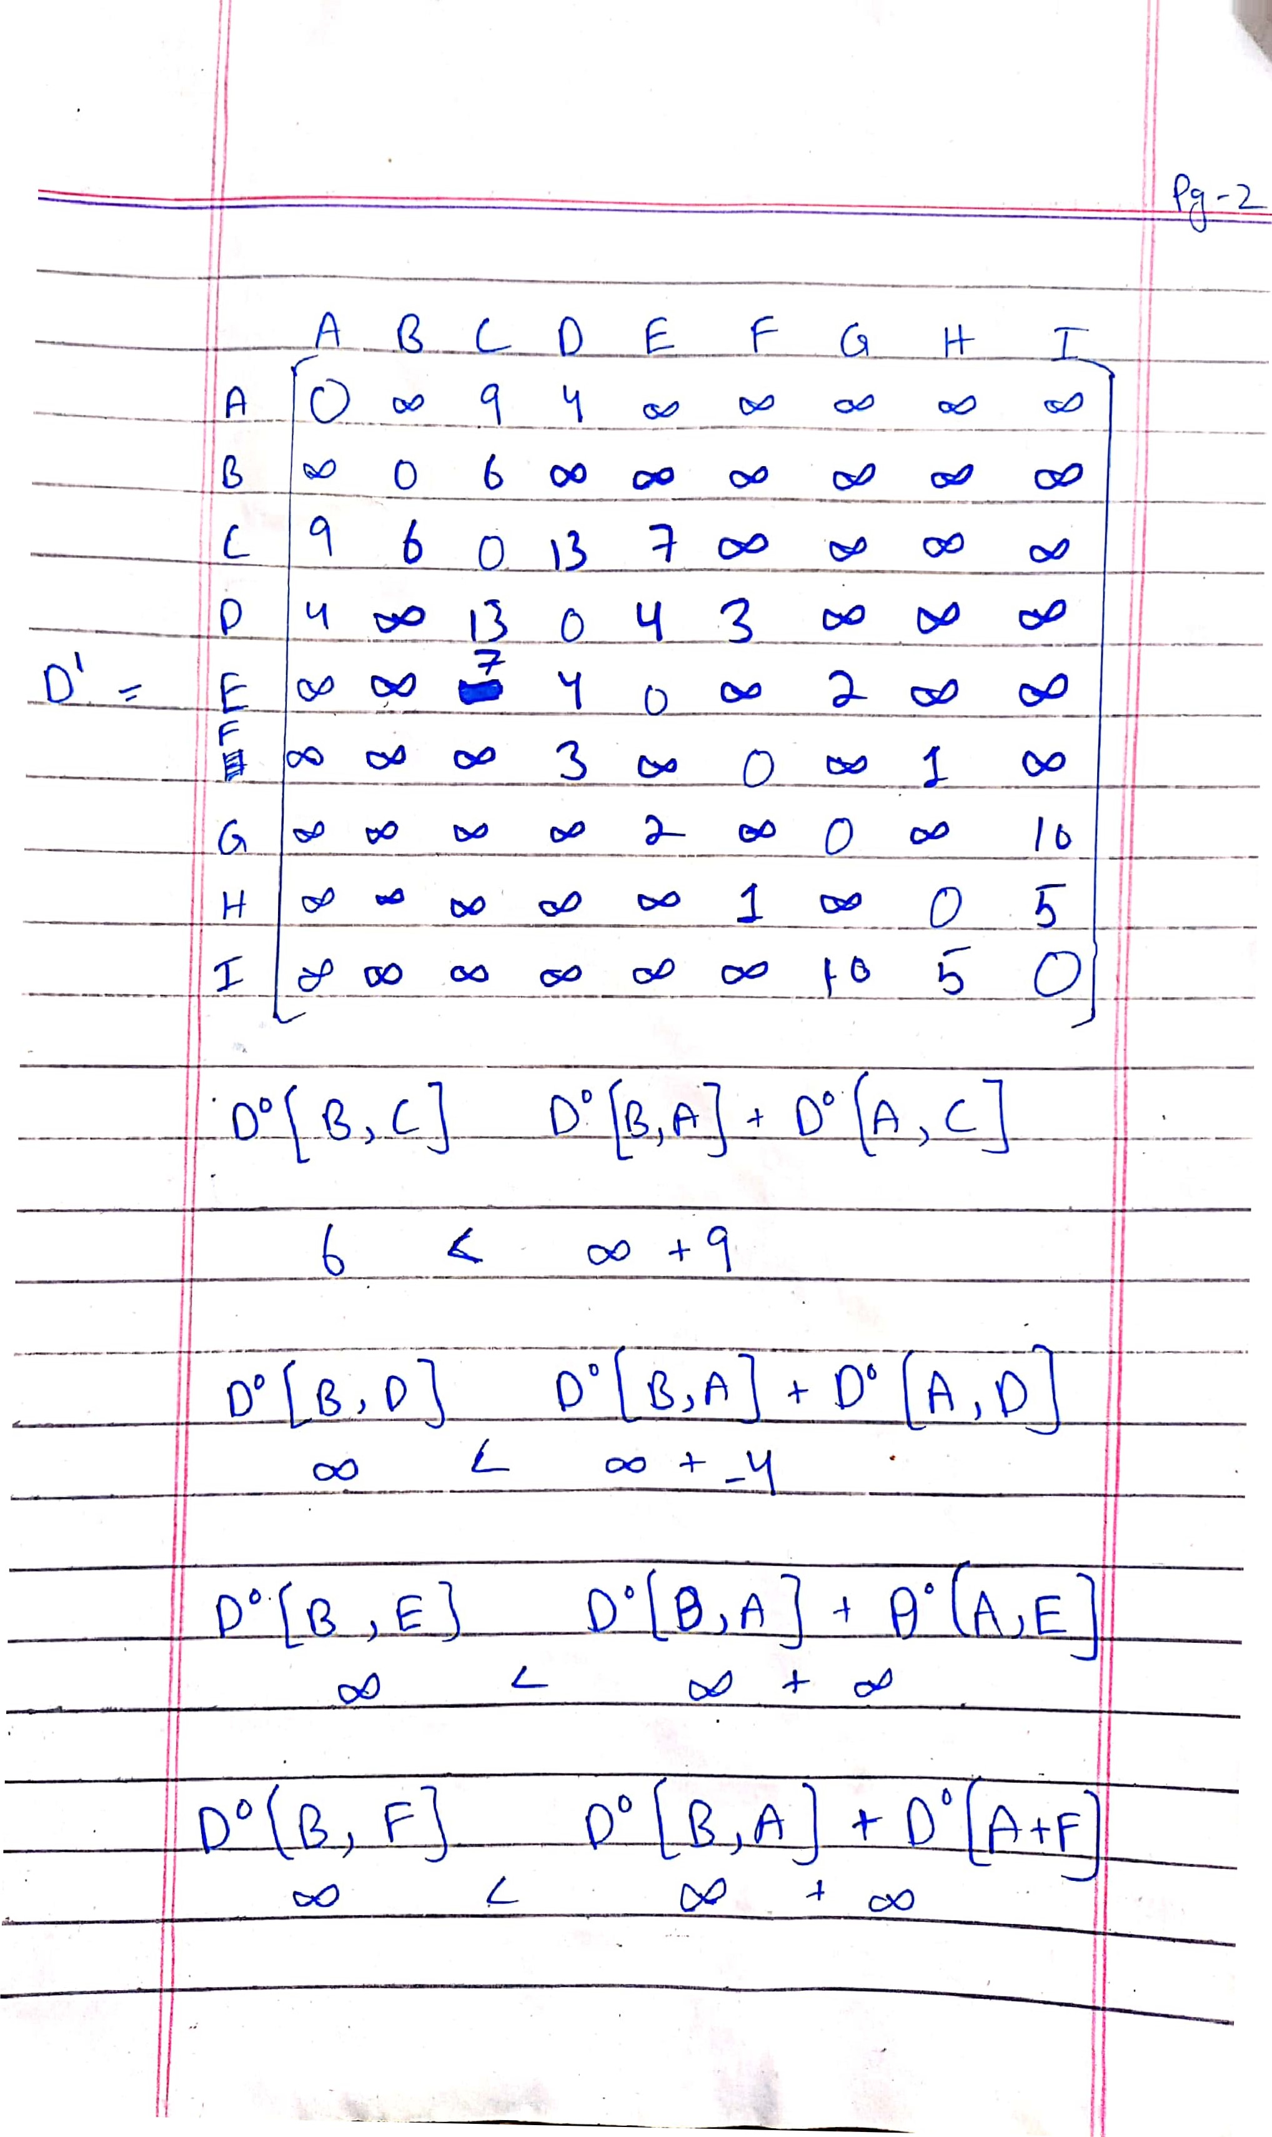

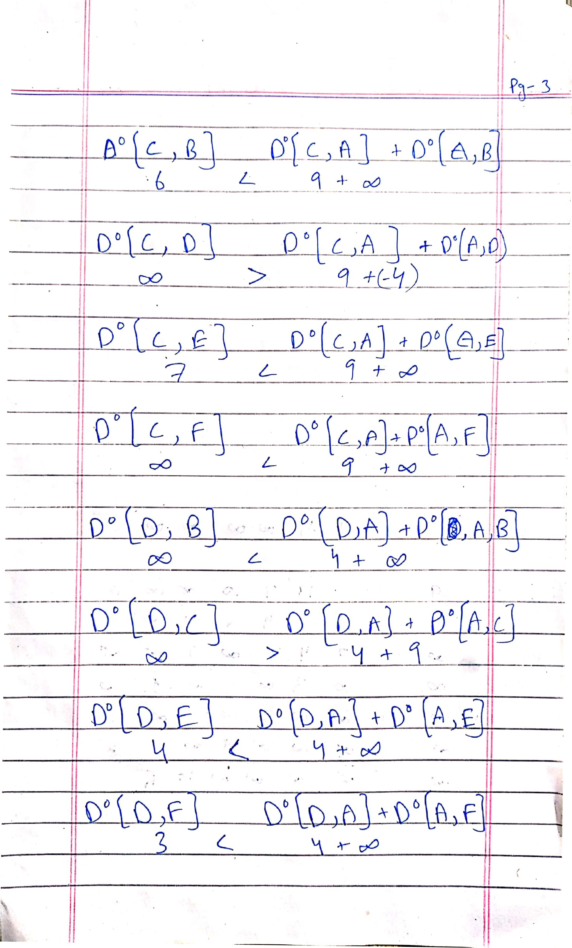

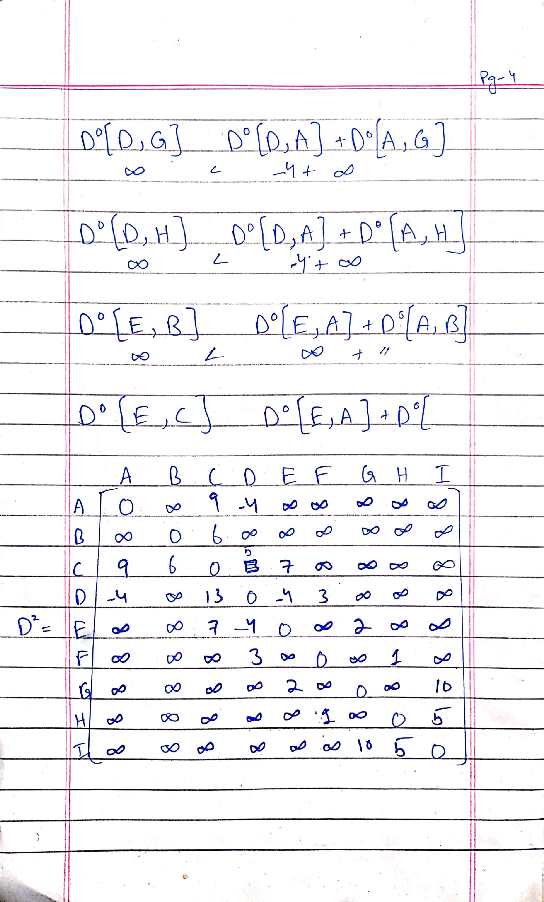

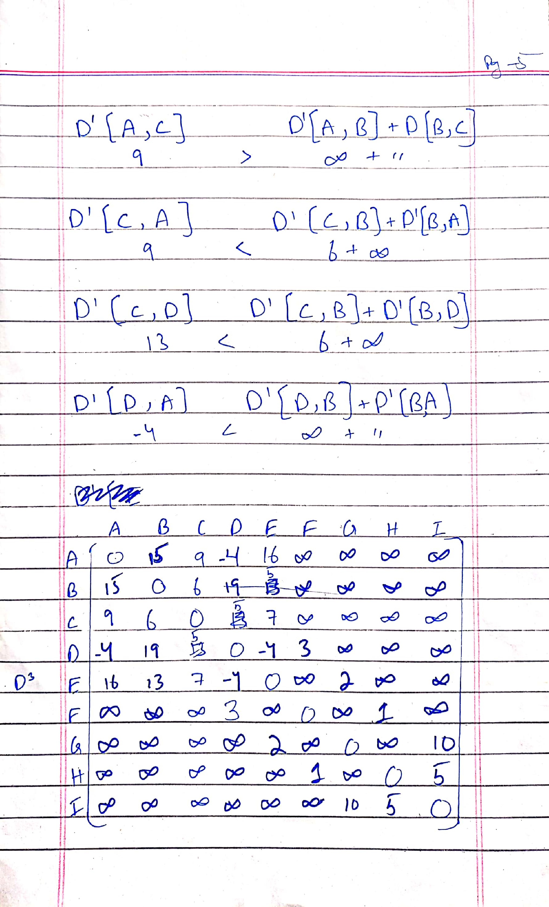

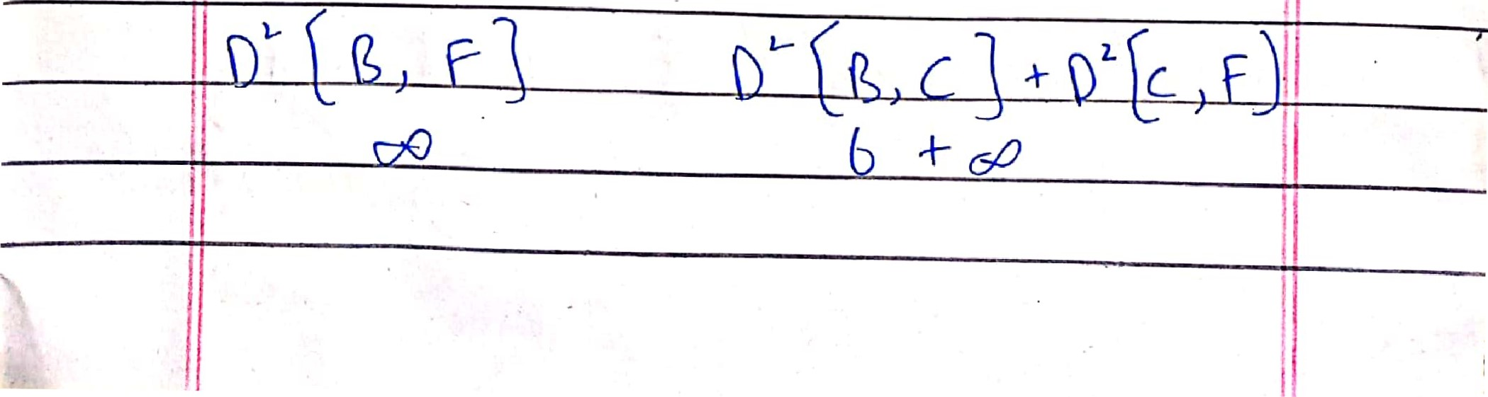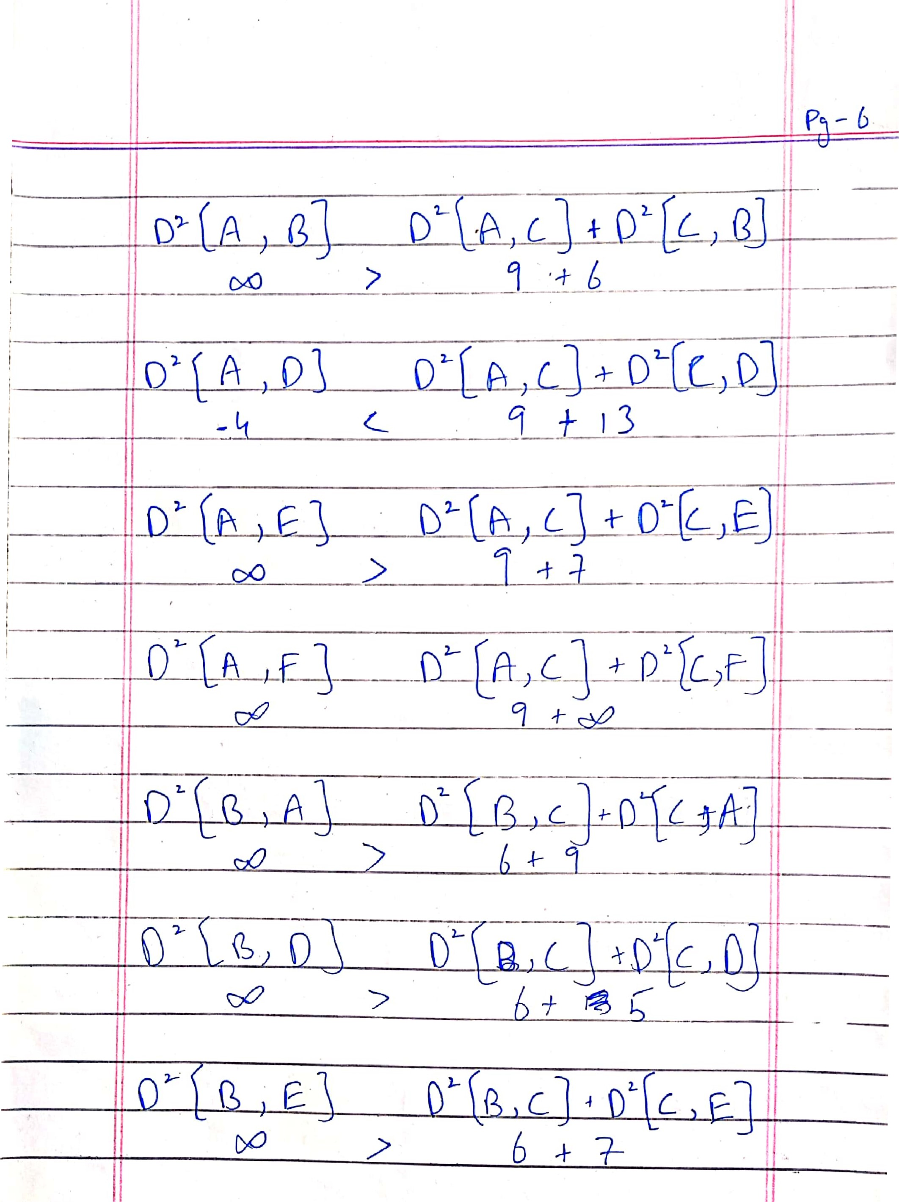

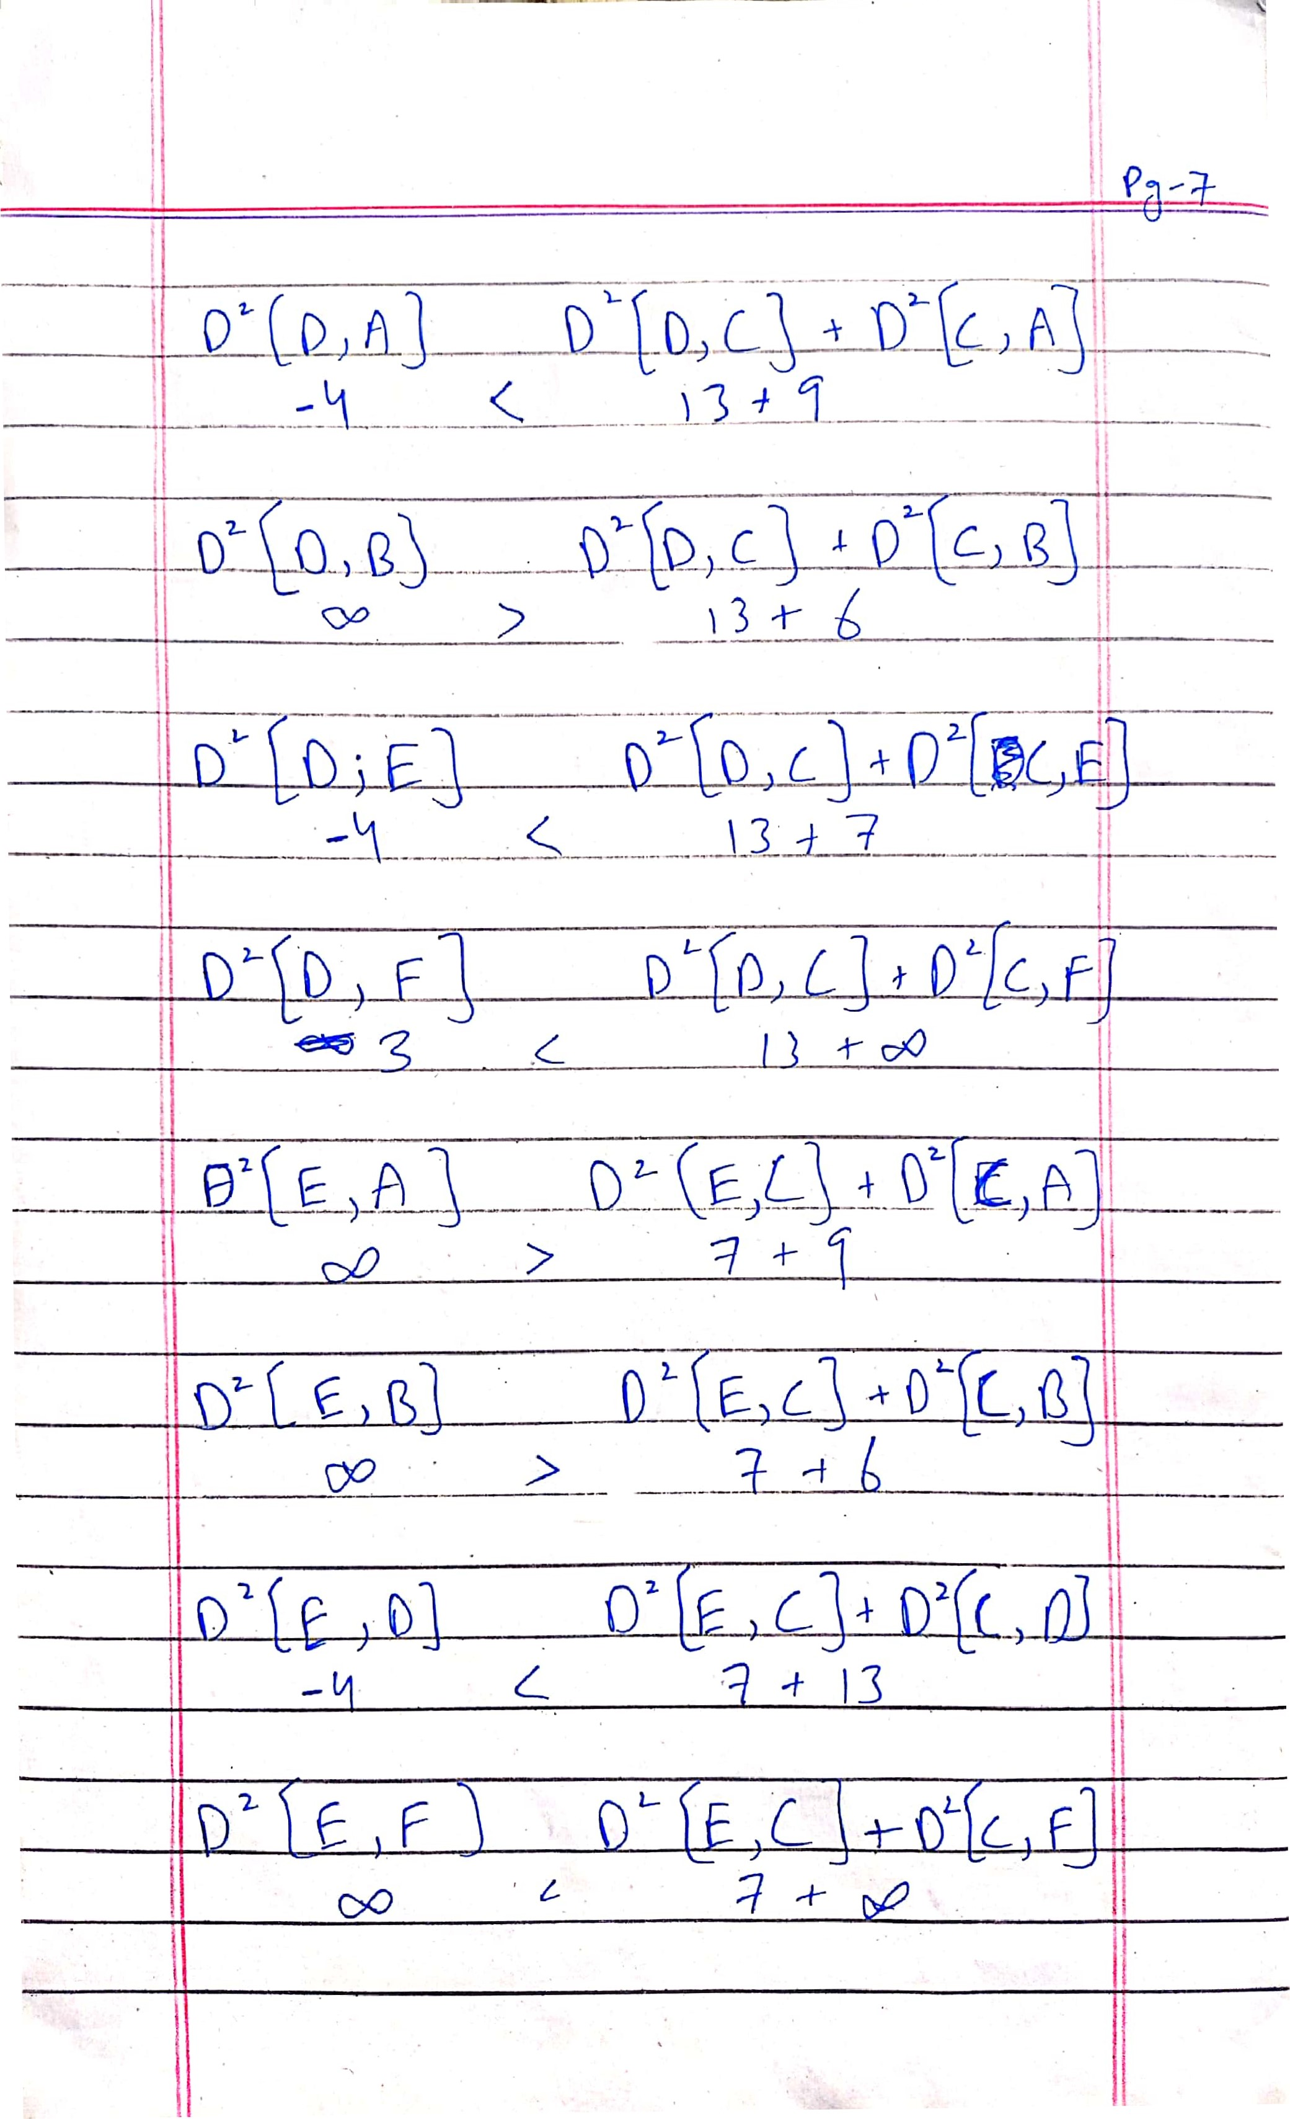

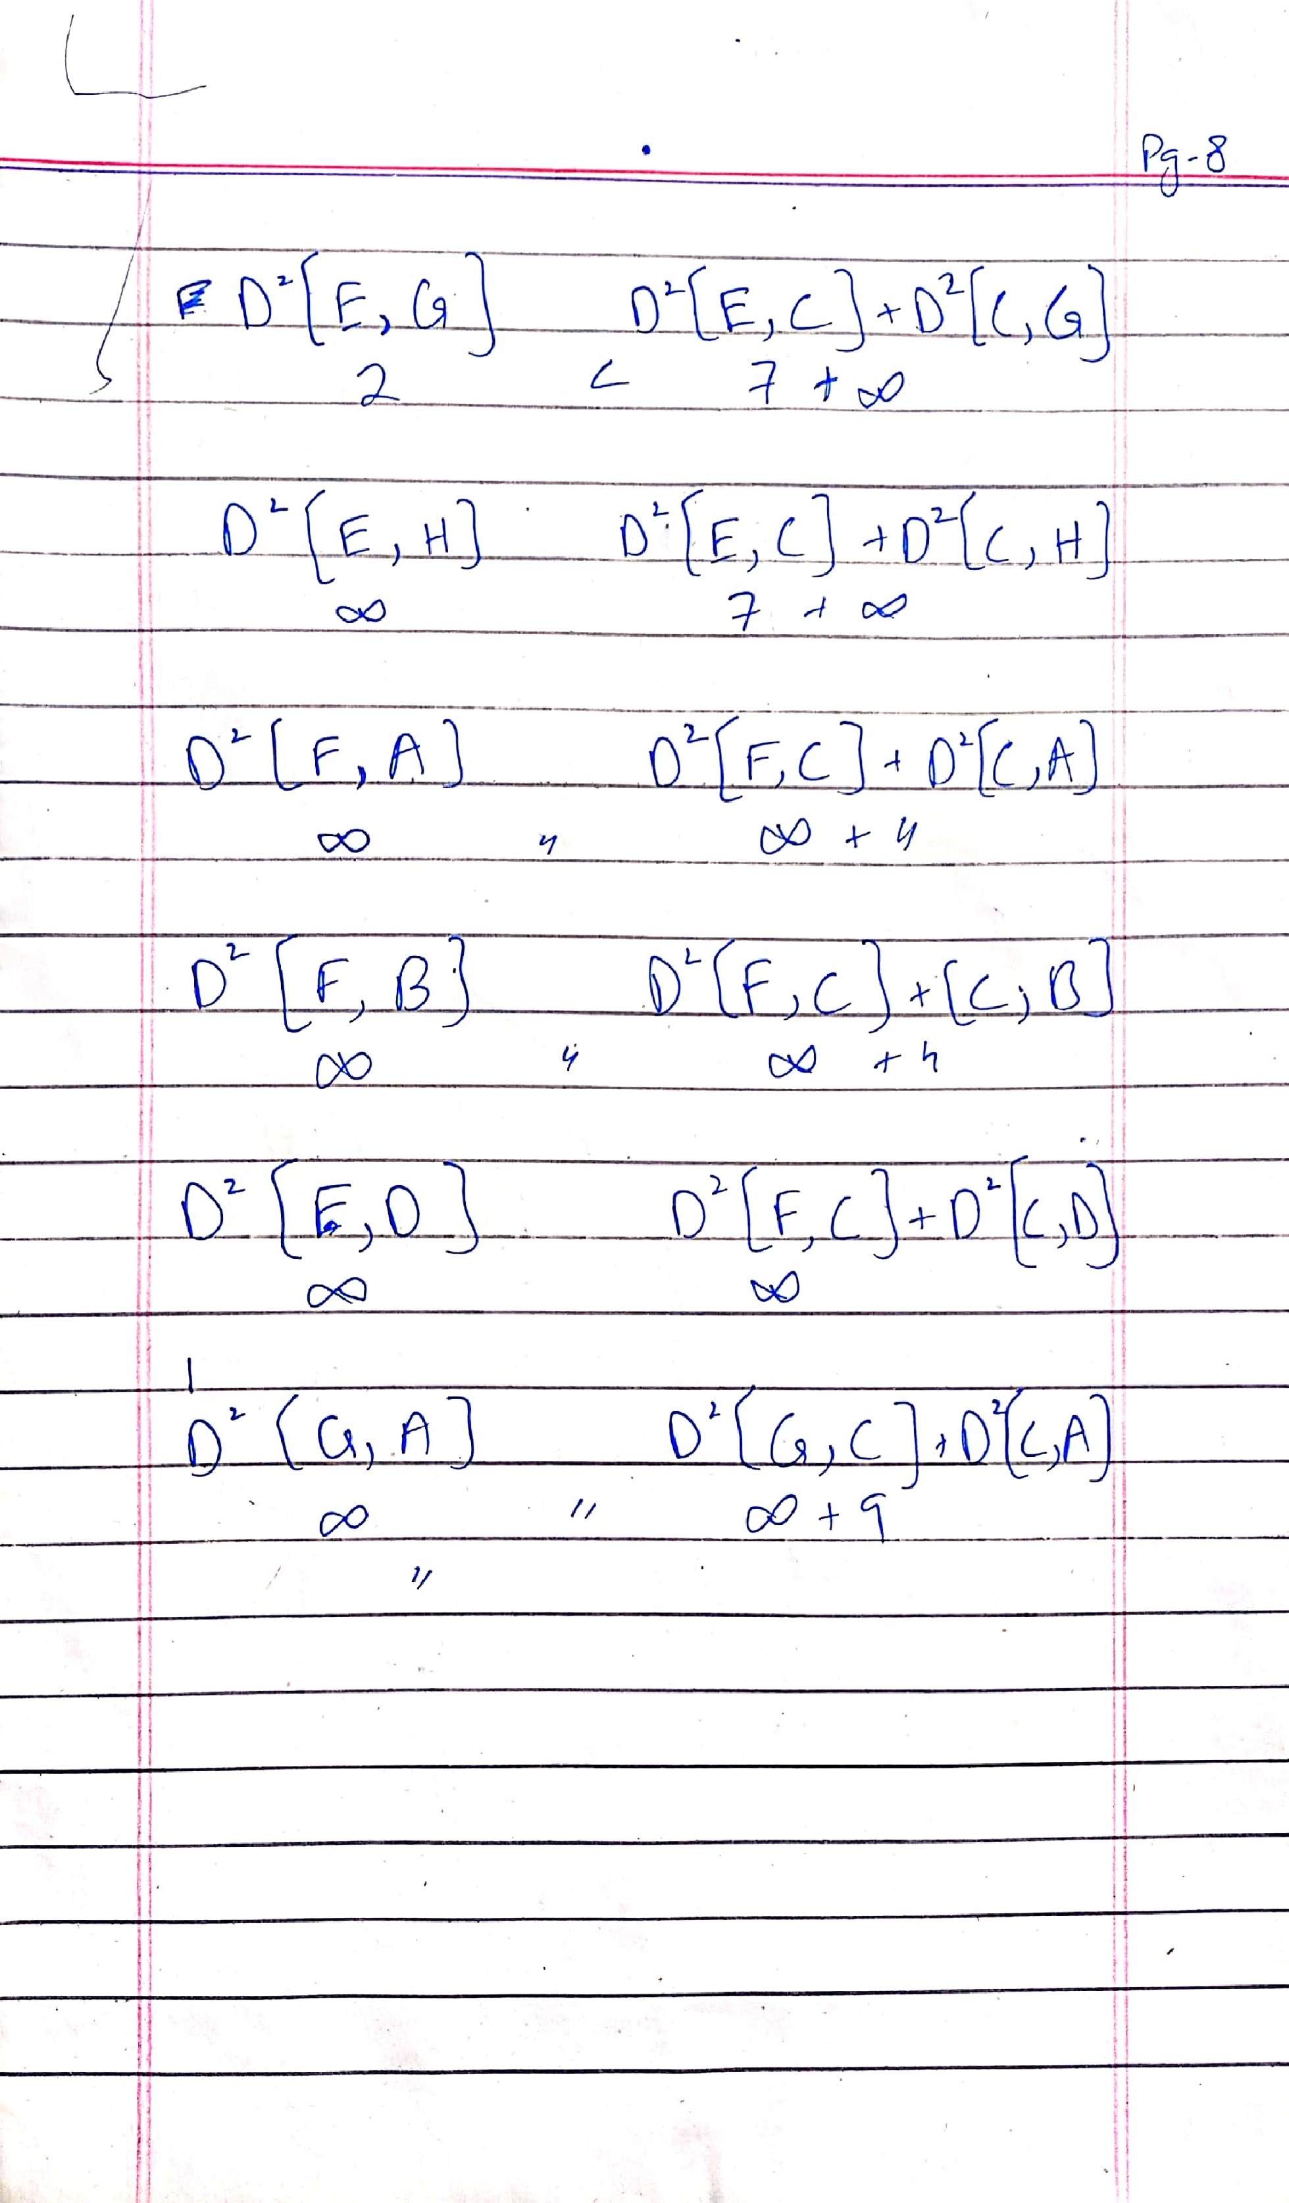

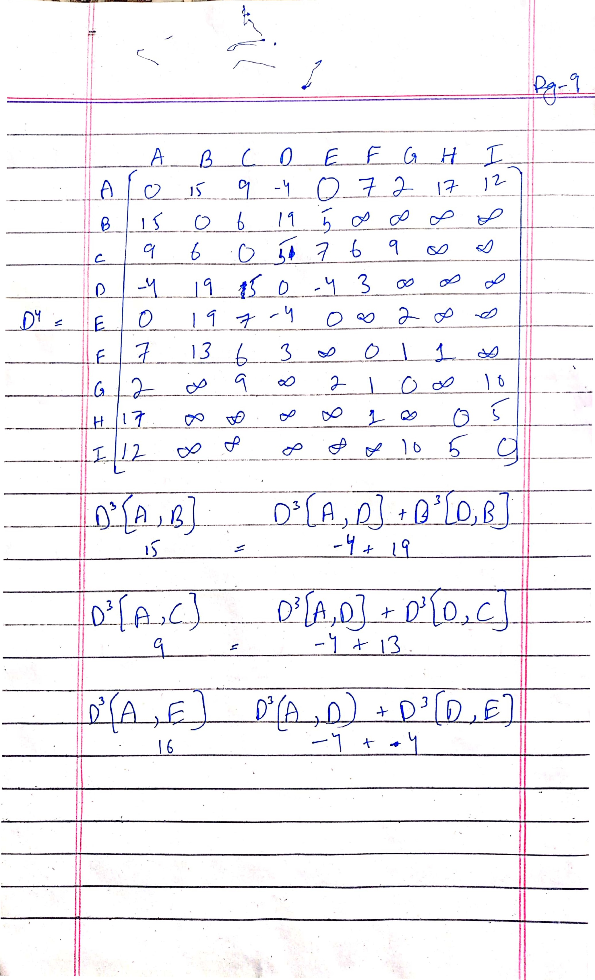

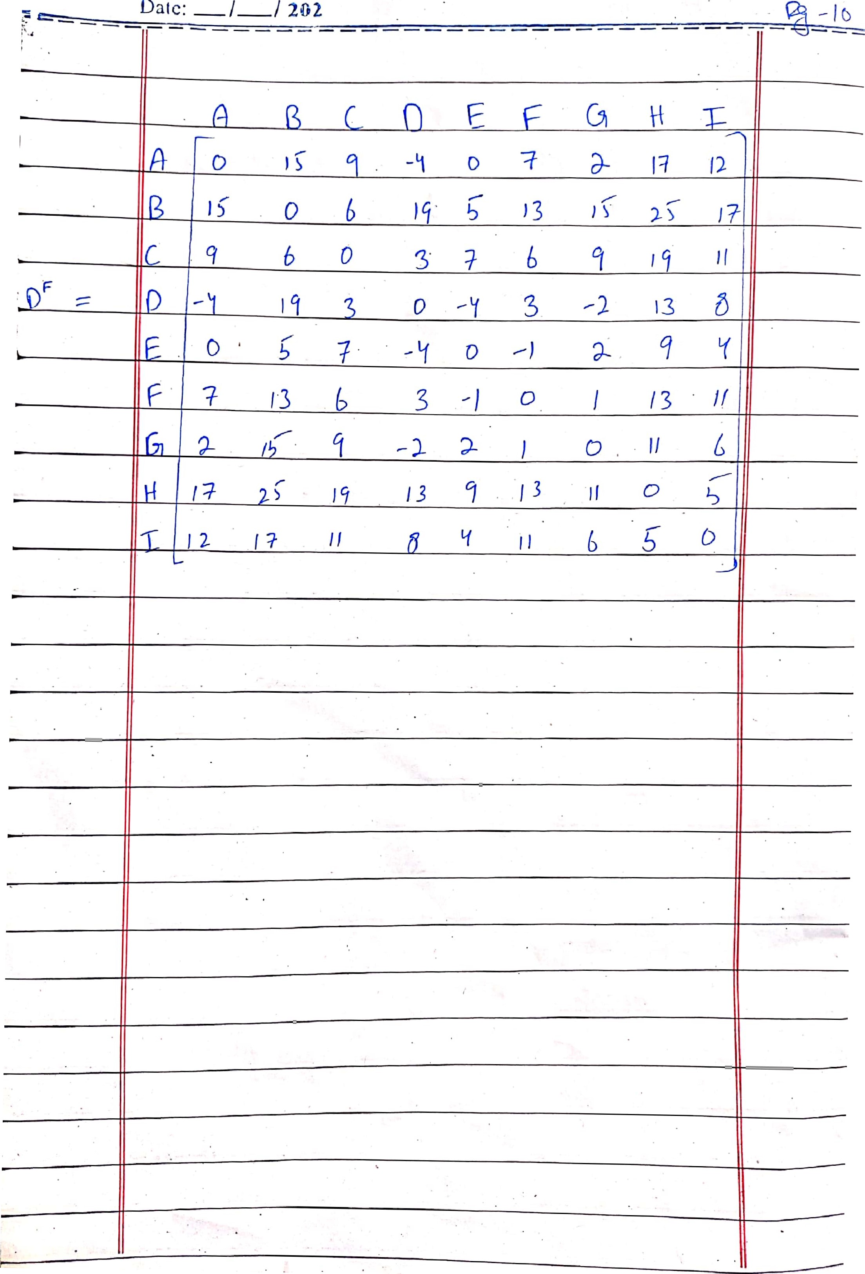

c) Explain the time complexity of Floyd-Warshall Algorithm.

